A

PROJECT REPORT

ON

**“THE YELLOW BACKPACK”**

Submitted To

MADHAV INSTITUTE OF TECHNOLOGY AND SCIENCE

A Govt. Aided UGC Autonomous Institute, Estd. In 1957

(Affilated to R.G.P.V.Bhopal)



IN PARTIAL FULFILLMENT FOR THE AWARD DEGREE

OF

BACHELOR OF ENGINEERING

IN

INFORMATION TECHNOLOGY

2017-2018

Under the Guidance of

Dr.SANJIV SHARMA

Department of Computer Science & Engineering and IT

MITS, Gwalior (M.P.)

Submitted By

APARNA RATHORE (0901 BT 141005)

KISHAN SHANKAR SINGHAL (0901 IT 141022)

MADHAV INSTITUTE OF TECHNOLOGY AND SCIENCE

GWALIOR (M.P.)

Department of Computer Science & Engineering and IT



**CERTIFICATE**

This is to certify that Aparna Rathore & Kishan Shankar Singhal students of Bachelor of Engineering In Information Technology of Madhav Institute of Technology and Science, Gwalior have completed their final semester project entitled “THE YELLOW BACKPACK”. They have submitted a satisfactory project report for the award of Degree of Bachelor Of Engineering in Information Technology.

To the best of my knowledge, the presented project report has not been submitted for the award of any other diploma or degree certificate.

Under the Supervision of:

Dr. SANJIV SHARMA Dr. AKHILESH TIWARI **Project Guide HOD Dept. of CSE & IT**                                       **Dept. of CSE & IT**

**Dr. R.K. PANDIT**

**Director**

**ACKNOWLEDGEMENT**

Preparing any project requires views of many people but we suspect that technical projects are more different than others. A great many people are involved in various stages of the project prepration who shared their knowledge and experience.

Before we get into thick of things we would like to add a few heartfelt words for the people who are part of this project in numerous ways people who gave un-ending support right from the stage idea was concieved.

It is our proud privilege to express a deep sense of gratitude and regard to our Project Guide **Dr. SANJIV SHARMA** (Dept.Of Computer Science & Engineering and IT) for the opportunity, he has given us for carrying out the project. His initiative, keen intrest, expert guidance at every step provided a constant source of inspiration and encouragement to us for intense studies in the subject. We are deeply indebted to him.

We shall be failing in our duty , if we do  not express our heart felt gratitude to **Dr. AKHILESH TIWARI** (Professor & Head) Department Of Computer Science & Engineering and IT, M.I.T.S. Gwalior for his support in the project.

We acknowledge with gratitude the benediction of our institution and Director, MITS, Gwalior who extended all facilities and co-operation in the completion of this project.

We also express sincere gratitude to **Shri Shankar Bannerjee, Shri Sanjay Arolia, Shri Santosh Sharma** and **Shri Imtiaz** for providing us the facilities which are at their disposal in the department computer laboratories. We owe our gratitude to our family and friends without whose co-operation and constant encouragement this work would not have been successful.

Our sincere thanks to all those who directly or indirectly helped us in the development and evolution of thoughts.

Aparna Rathore

Kishan Shankar Singhal

 **Madhav Institute of Technology & Science, Gwalior - 474005 (M.P)**

**(An Autonomous Institute under R.G.P.V, Bhopal, M.P.)**

**Department of CSE & IT**

**DECLARATION**

We, Aparna Rathore & Kishan Shankar Singhalstudents of Bachelor of Engineeringin Information Technologyhereby declare that the major project entitled “THE YELLOW BACKPACK” which is being submitted to Department of CSE & ITin MITS, Gwalioris my authentic work carried out for submitting as a major project during VIII semester. This work has not been submitted in part or full to this or any other university for the award of degree to the best of our knowledge.

Place: Gwalior

**Aparna Rathore Kishan Shankar Singhal**

**(0901 BT 141005) (0901 IT 141022)**

**THE YELLOW BACKPACK**

**A Travel itinerary at your place……….**

**TABLE OF CONTENTS**

1. **INTRODUCTION 7**
   1. Goals & Purpose 7
   2. Need of application 7
   3. Scope of the project 8
   4. Technical Description 8
2. **SYSTEM STUDY 13**
   1. Existing System along with limitations and deficiencies 13
   2. Proposed System along with intended objectives 13
   3. Feasibility Study 13
      1. Operational Feasibility 14
      2. Technical Feasibility 14
      3. Economic Feasibility 14
3. **SYSTEM ANALYSIS 15**
   1. Requirement Specifications 15
   2. System Flowcharts 17
      1. ER diagram 17
      2. USE CASE Diagram 18
      3. Data Flow Diagram (DFD) 19
   3. Software Requirements 20
   4. Hardware Requirements 20
   5. Model Used 20
4. **SYSTEM DESIGN 23**
   1. Program Design 23
   2. Input & Output Form Design 23
5. EXTERNAL INTERFACE REQUIREMENTS 24
   1. User Interfaces 24
   2. Hardware Interfaces 24
   3. Software Interfaces 24
   4. Communications Interfaces 24
   5. User Interface Design 25
6. **SYSTEM TESTING 32**
   1. White-box Testing 33
   2. Black-box Testing 34
7. **CONCLUSION**  35
8. **WEB REFERENCES & BIBLIOGRAPGY**  36

1. **INTRODUCTION**

The Yellow Backpack is a website furnishing the user with a travel itinerary of the places that the team has visited or has relevant information about. All the details of the project which are mandatory to know, can be deemed through the stated heads and the upcoming chapters as follows.

* 1. **Goals & Purpose**

The impetus behind building The Yellow Backpack is to plan a perfect trip without spending much money and time.

As travelers took planning into their own hands, their hands got pretty full, and their lives got pretty frantic. Yellow Backpack set out to change all that.

**To bring calm to the chaos, Peace of mind to the panic**.

And so the spoon-feeding travel organizing website was born.

If given a chance the team can add embellishments to the project and make it worth selling by including the advertisements from various other travelling websites, hotels, cabs booking forums etc.

* 1. **Need of Application**

As the name suggests yellow backpack is composed of yellow pages and every book is made for the reader to read and grasp what it has to serve on the plate. So, this project serves the needs of the travelers who earlier used to hunt different websites for planning the trips, keeping track of the stuff to carry, what all spots to visit, which booking sites to refer for the same and much more related information. The project caters all these requirements.

* We made it auto magical, so all you have to do is select a destination and pack to leave.
* We made it accessible, so you can see all your travel plans in one place, on any device.
* We made it free, because the best things in life usually are.
  1. **Scope of the Project**
* The project should include an active website along with the trailing links.
* It is limited to local machines for now.
* Its making requires at least 1 skilled person.
* It should be user friendly.
* The text should be readable and pictures well related to the context.
* It should get completed in a span of 60 days.
* It should have HOME, ABOUT, TOUR, CONTACT, SIGNUP, and LOGIN navigation bars.
* The content, pictures, code etc. all should be self-made and not plagiarized.
  1. **Technical Description**

The tools used for developing the application include the following :

1. PHP language.

2. Wamp Server.

3. Netbeans.

4. HTML & CSS

**1. PHP:**

PHP started out as a small open source project that evolved as more and more people found out how useful it was. Rasmus Lerdorf unleashed the first version of PHP way back in 1994.

* PHP is a recursive acronym for "PHP: Hypertext Preprocessor".
* PHP is a server side scripting language that is embedded in HTML. It is used to manage dynamic content, databases, session tracking, even build entire e-commerce sites.
* It is integrated with a number of popular databases, including MySQL, PostgreSQL, Oracle, Sybase, Informix, and Microsoft SQL Server.
* PHP is pleasingly zippy in its execution, especially when compiled as an Apache module on the Unix side. The MySQL server, once started, executes even very complex queries with huge result sets in record-setting time.
* PHP supports a large number of major protocols such as POP3, IMAP, and LDAP. PHP4 added support for Java and distributed object architectures (COM and CORBA), making n-tier development a possibility for the first time.
* PHP is forgiving: PHP language tries to be as forgiving as possible.
* PHP Syntax is C-Like.

**Uses of PHP**

PHP performs system functions, i.e. from files on a system it can create, open, read, write, and close them. The other uses of PHP are:

* PHP can handle forms, i.e. gather data from files, save data to a file, thru email you can send data, return data to the user.
* You add, delete, and modify elements within your database through PHP.
* Access cookies variables and set cookies.
* Using PHP, you can restrict users to access some pages of your website.
* It can encrypt data.

**Characteristics of PHP**

Five important characteristics make PHP's practical nature possible:

* Simplicity
* Efficiency
* Security
* Flexibility
* Familiarity

**2. WAMPP Server**:

**WampServer** refers to a [software stack](https://en.wikipedia.org/wiki/Solution_stack) for the [Microsoft Windows](https://en.wikipedia.org/wiki/Microsoft_Windows) operating system, created by Romain Bourdon and consisting of the [Apache web server](https://en.wikipedia.org/wiki/Apache_HTTP_Server), [OpenSSL](https://en.wikipedia.org/wiki/OpenSSL) for SSL support, [MySQL](https://en.wikipedia.org/wiki/MySQL) database and [PHP](https://en.wikipedia.org/wiki/PHP) programming language.

Alongside, PhpMyAdmin allows you to manage easily your databases. This acts as a local database management server. For the database access, separate codes are written using Java beans.

* **FUNCTIONALITIES**

WampServer’s functionalities are very complete and easy to use so we won’t explain here how to use them.

**With a left click** on WampServer’s icon, you will be able to:

* manage your Apache and MySQL services
* switch online/offline (give access to everyone or only localhost)
* install and switch Apache, MySQL and PHP releases
* manage your servers settings
* access your logs
* access your settings files
* create alias

**With a right click:**

* change WampServer’s menu language
* access this page

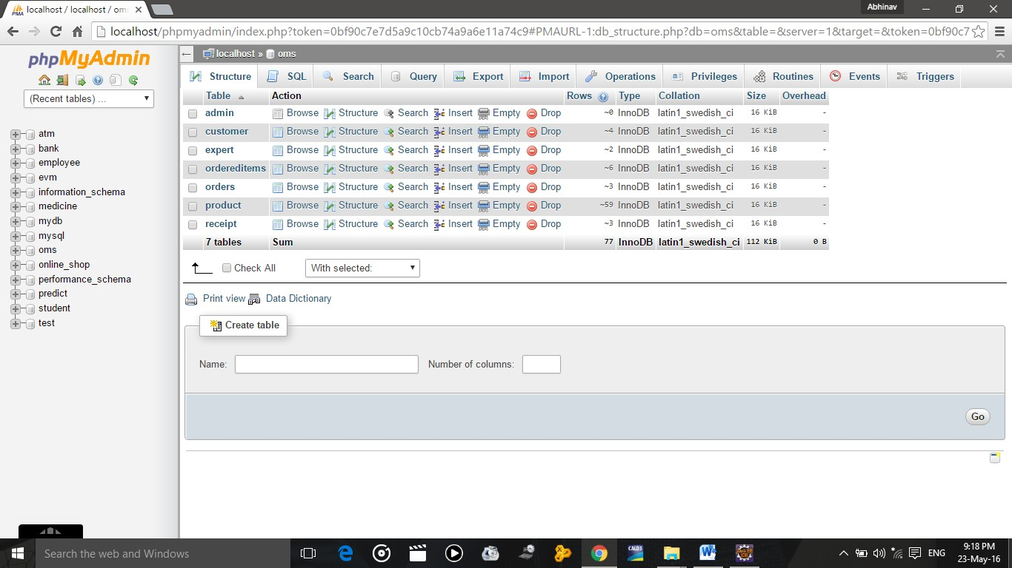

**Fig 1.1 Wamp Server Database**

**3. NETBEANS 8.2:**

|  |
| --- |
| The NetBeans Platform is a generic framework for Swing applications. It provides the "plumbing" that, before, every developer had to write themselves—saving state, connecting actions to menu items, toolbar items and keyboard shortcuts; window management, and so on.  The NetBeans Platform provides all of these out of the box. You don't need to manually code these or other basic features, yourself, anymore. See what [some NetBeans-based applications look like](https://platform.netbeans.org/screenshots.html). The platform does not add a lot of overhead to your application — but it can save a huge amount of time and work. |

The NetBeans Platform provides a reliable and flexible application architecture. Your application [does not have to look anything like an IDE](https://netbeans.org/images_www/screenshots/platform/blueMarine.jpg). It can save you years of development time. The NetBeans Platform gives you a time-tested architecture for free. An architecture that encourages sustainable development practices. Because the NetBeans Platform architecture is modular, it's easy to create applications that are robust and extensible.

**4. HTML & CSS:**

**HTML:**

HTML stands for Hypertext Markup Language, and it is the most widely used language to write Web Pages.

* Hypertext refers to the way in which Web pages (HTML documents) are linked together. Thus, the link available on a webpage is called Hypertext.
* As its name suggests, HTML is a Markup Language which means you use HTML to simply "mark-up" a text document with tags that tell a Web browser how to structure it to display.

Originally, HTML was developed with the intent of defining the structure of documents like headings, paragraphs, lists, and so forth to facilitate the sharing of scientific information between researchers.

Now, HTML is being widely used to format web pages with the help of different tags available in HTML language.

**CSS:**

Cascading Style Sheets, fondly referred to as CSS, is a simple design language intended to simplify the process of making web pages presentable.

CSS handles the look and feel part of a web page. Using CSS, you can control the color of the text, the style of fonts, the spacing between paragraphs, how columns are sized and laid out, what background images or colors are used, layout designs, and variations in display for different devices and screen sizes as well as a variety of other effects.

CSS is easy to learn and understand but it provides powerful control over the presentation of an HTML document. Most commonly, CSS is combined with the markup languages HTML or XHTML.

## Advantages of CSS:

* CSS saves time − You can write CSS once and then reuse same sheet in multiple HTML pages. You can define a style for each HTML element and apply it to as many Web pages as you want.
* Pages load faster − If you are using CSS, you do not need to write HTML tag attributes every time. Just write one CSS rule of a tag and apply it to all the occurrences of that tag. So less code means faster download times.
* Easy maintenance − To make a global change, simply change the style, and all elements in all the web pages will be updated automatically.
* Superior styles to HTML − CSS has a much wider array of attributes than HTML, so you can give a far better look to your HTML page in comparison to HTML attributes.
* Multiple Device Compatibility − Style sheets allow content to be optimized for more than one type of device. By using the same HTML document, different versions of a website can be presented for handheld devices such as PDAs and cell phones or for printing.
* Offline Browsing − CSS can store web applications locally with the help of an offline catche.Using of this, we can view offline websites.The cache also ensures faster loading and better overall performance of the website.
* Platform Independence − The Script offer consistent platform independence and can support latest browsers as well.

1. **SYSTEM STUDY**

This involves the description of the significance of the website, its uses, advantages and pitfalls of already proposed similar apps or web-apps, and all the feasibility studies involved in the making of the same.

* 1. **Existing System along with limitations/deficiencies**

Websites that book the trips, hotels, conveyance and avail the user with other facilities usually forget the plan behind making this trip of theirs a successful one.

Where some websites do the bookings of hotels (ex. Makemytrip.com), others book conveyance (ex. Ola, Uber) and yet another website will tell you the places to visit (ex. spotify.com) and one another website will plan your itinerary (ex.travify.com), The Yellow Book caters to all the needs at once.

We save the user from running on to different pages and jotting down stuff as we provide every detail related to the trip.

* 1. **Proposed System along with intended objectives**

The proposed project gives you an itinerary and various booking deals about various places visited by the team or they have information collected.

The places are categorized into SummerLand, WinterLand and DesertLand. Each land specifies a number of cities. If a traveler wishes to visit the city he can get all the information regarding what to carry, which places/spots to visit, which route to follow and by what conveyance. An additional page of Frequently Asked Questions (FAQs) is also maintained to aid the user.

All in all, the website provides the user with a perfect planned trip.

* 1. **Feasibility Study**

A feasibility study tests the viability of an idea or a project. The goal of a feasibility study is to place emphasis on potential problems that could occur if a project is pursued and determine if, after all significant factors are considered, the project should be pursued or not. It addresses where and how it will operate, potential obstacles, competition and the funding needed to get the business up and running.

**2.3.1 Operational Feasibility**

The proposed system can be fully implemented to fulfill the requirements accompanied by various tools needed from time to time.

This includes:

* **Process** – It should be clear and well adapted to the user’s requirements.
* **Evaluation** – The process will work within the scope of the project.
* **Implementation** – Stakeholder, manager, and end-user tasks will be shown effectively.
* **In-House Strategies** – Environment will be a bit affected by the use of resources.
* **Adapt & Review** –The new process will be implemented here along with a review process to monitor the process change.

**2.3.2 Technical Feasibility**

In technical feasibility the following issues are taken into consideration.

Whether the required technology is available or not

Whether the required resources are available -  
- Manpower- programmers, testers & debuggers are available  
- Software and hardware are also available and work well with the system incorporated.

**2.3.3 Economic Feasibility**

The project is economically feasible as it uses basic resources like Internet, manpower and the personal or college computers. For any system if the expected benefits equal or exceed the expected costs, the system can be judged to be economically feasible for which we have done the analysis that includes expected costs and benefits evaluation. Economic analysis is used for evaluating the effectiveness of the proposed system.

Cost-benefit analysis is also performed. As the name suggests, it is an analysis of the costs to be incurred in the system and benefits derivable out of the system.

1. **SYSTEM ANALYSIS**
   1. **Requirement Specifications**

**Functional Requirements:**

The requirements of the website are specified as under:

**Functionality**:

* The system shall display all the places that can be configured.
* The system shall allow user to select the place to configure.
* The system shall display all the available components of the place to configure
* The system shall enable user to add one or more component to the configuration.
* The system shall notify the user about any conflict in the current configuration.
* The system shall allow user to update the configuration to resolve conflict in the current configuration.
* The system shall display detailed information of the selected place.
* The system shall provide browsing options to see place details.

**Provide Search facility.**

* The system shall enable user to enter the search text on the screen.
* The system shall enable user to select multiple options on the screen to search.
* The system shall display all the matching products based on the search.
* The system shall display only 10 matching result on the current screen.
* The system shall enable user to navigate between the search results.
* The system shall notify the user when no matching product is found on the search.

**Maintain customer profile**.

* The system shall allow user to create profile and set his credential.
* The system shall authenticate user credentials to view the profile.
* The system shall allow user to update the profile information.

**Provide personalized profile**

* The system shall display the most frequently searched items by the user in the profile.
* The system shall allow user to register for newsletters and surveys in the profile.

### **Provide Customer Support.**

* The system shall provide online help, FAQ’s customer support, and sitemap options for customer support.
* The system shall allow user to select the support type he wants.
* The system shall display the customer support contact numbers on the screen.
* The system shall display the online help upon request.
* The system shall display the FAQ’s request.

### 

### **Provide detailed sitemap.**

* The system shall allow user to view detailed sitemap.

### **Offer online promotions and rewards.**

* The system shall display all the available promotions to the user.
* The system shall allow user to select available promotion.

## 

## Usability

### **Graphical User Interface**

* The system shall provide a uniform look and feel between all the web pages.
* The system shall provide a digital image for each product in the product catalog.
* The system shall provide use of icons and toolbars.

## Reliability & Availability

## Performance

* The product shall be based on web and has to be run from a web server.
* The product shall take initial load time depending on internet connection strength which also depends on the media from which the product is run.
* The performance shall depend upon hardware components of the client/customer.

### **Data Storage**

* The customer’s web browser shall never display a customer’s password. It shall always be echoed with special characters representing typed characters.
* The system’s back-end servers shall only be accessible to authenticated administrators.
* The system’s back-end databases shall be encrypted.
  1. **System Flowcharts**

These flowcharts represent a better way to analyze all the requirements and hence are here as shown. Each diagram has its very own significance.

* + 1. **ER Diagram**

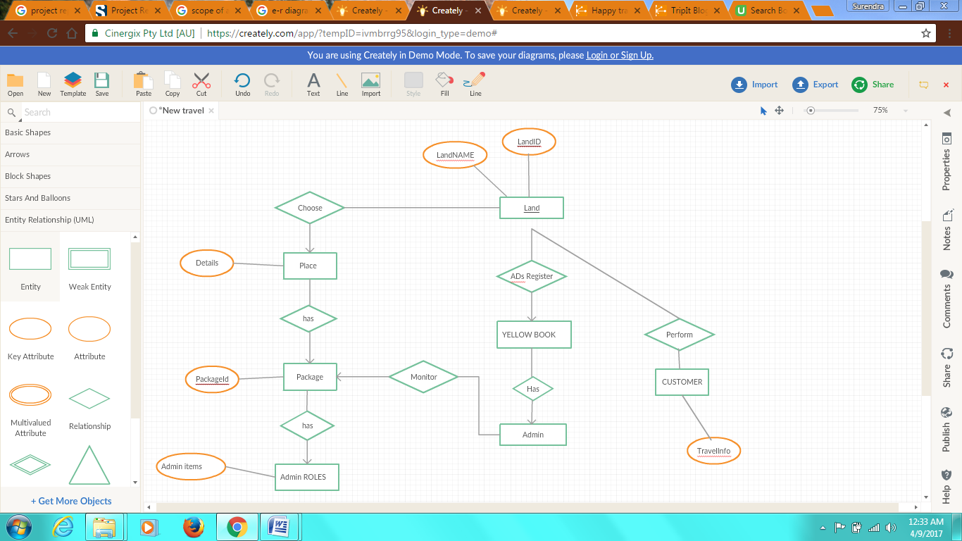

**Fig 3.1 E-R DIAGRAM**

An entity relationship diagram (ERD), also known as an entity relationship model, is a graphical representation of an information system that depicts the relationships among people, objects, places, concepts or events within that system. An ERD is a [data modeling](https://searchdatamanagement.techtarget.com/definition/data-modeling) technique that can help define business processes and be used as the foundation for a [relational database](https://searchsqlserver.techtarget.com/definition/relational-database).

* + 1. **Use Case Diagram**

A **use case diagram** at its simplest is a representation of a user's interaction with the system that shows the relationship between the user and the different [use cases](https://en.wikipedia.org/wiki/Use_case) in which the user is involved. A use case diagram can identify the different types of users of a system and the different use cases and will often be accompanied by other types of diagrams as well.

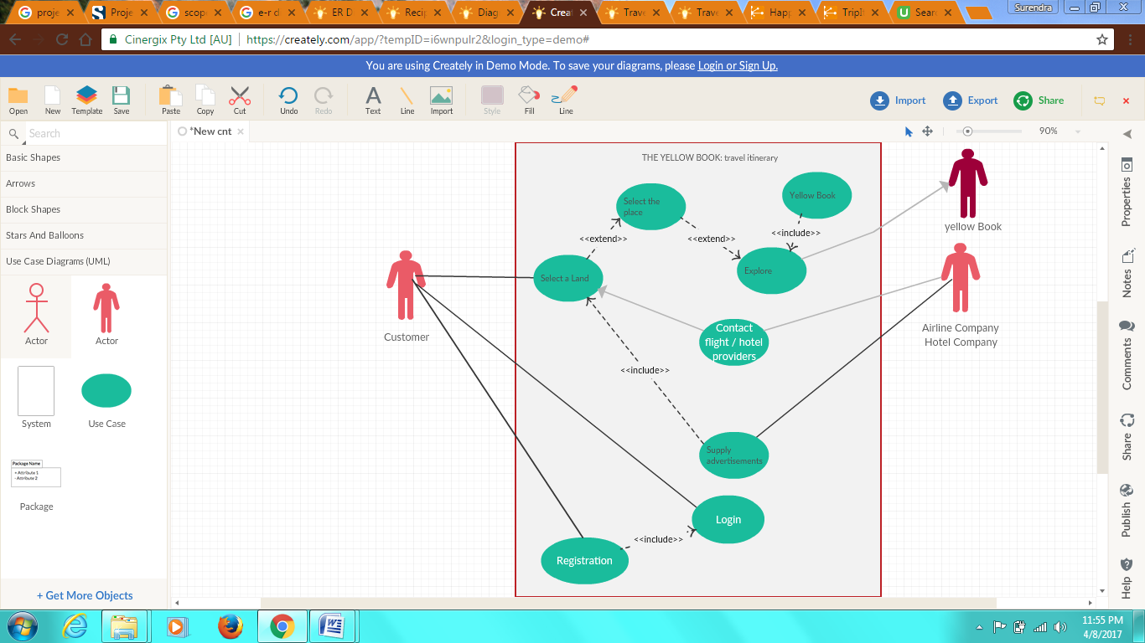

**Fig 3.2 USE CASE DIAGRAM**

* + 1. **Data-flow diagrams :**

Data flow diagrams are used to graphically represent the flow of data in a business information system. DFD describes the processes that are involved in a system to transfer data from the input to the file storage and reports generation.

Data flow diagrams can be divided into logical and physical. The logical data flow diagram describes flow of data through a system to perform certain functionality of a business. The physical data flow diagram describes the implementation of the logical data flow.

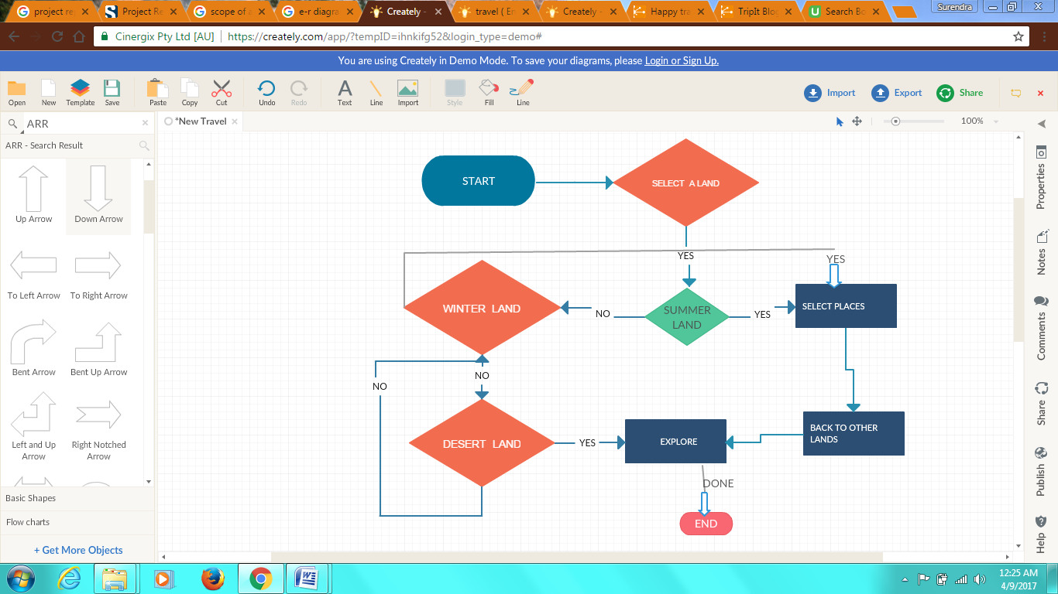

**Fig 3.3 DATA FLOW DIAGRAM**

# SOFTWARE REQUIREMENTS

* Windows operating system.
* Front End: HTML, CSS.
* Web browsers like Chrome, Mozilla Firefox, Microsoft Edge, etc.
* Back End: MY-SQL.
* WAMP Server for database Connectivity.
* Programming Languages used: HTML and CSS.

# HARDWARE REQUIREMENTS

* Pentium IV Processer or Above.
* 1GB SD RAM
* 1.7 GHz Processor
* Min 1 GB of disk space
* 1024*768 Resolution or higher
  1. **MODEL USED - WATERFALL MODEL**

The **waterfall model** is a sequential design process, often used in [software development processes](http://en.wikipedia.org/wiki/Software_development_process), in which progress is seen as flowing steadily downwards (like a [waterfall](http://en.wikipedia.org/wiki/Waterfall)) through the phases of Conception, Initiation, [Analysis](http://en.wikipedia.org/wiki/Analysis), [Design](http://en.wikipedia.org/wiki/Software_design), Construction, [Testing](http://en.wikipedia.org/wiki/Software_testing), [Production/Implementation](http://en.wikipedia.org/wiki/Implementation) and [Maintenance](http://en.wikipedia.org/wiki/Software_maintenance).

* The waterfall model is documentation-intensive, with earlier phases documenting what must be done and subsequent phases adding greater detail and defining how it should be done. The output from one phase serves as the input to the next phase, with the project flowing from one step to the next in a waterfall fashion. Phases are assumed to be sequential, with only localized feedback during the transition between phases. Comprehensive reviews validate the work of one phase, and require the resolution of any problems before development is allowed to proceed to the next phase. An important consideration for the Waterfall model is that fixes or modifications are often put off until the maintenance phase. This can be very costly, as the cost to correct a problem gets higher with each successive phase.

**Advantages**

* System is well documented.
* Phases correspond with project management phases.
* Cost and schedule estimates may be lower and more accurate.
* Details can be addressed with more engineering effort if software is large or complex.

**Disadvantages**

1. All risks must be dealt with in a single software development effort. Because the model is sequential; there is only local feedback at the transition between phases.
2. A working product is not available until late in the project.

**Application**

The Waterfall model can be successfully used when requirements are well understood in the beginning and are not expected to change or evolve over the life of the project. Project risks should be relatively low.

This model is applied in project in the following manner.

1. Requirements are gathered, like appropriate system specification or particular facility needed by the user.
2. Model appropriate Data flow diagram for Security cam, which will describe the appropriate flow of data and functions throughout the project.
3. Code will be implemented on the basis of modeled data flow diagram and requirements.
4. Proper verification methods will be applied in order to test the constructed code.
5. Last step will include maintenance for the above proposed project.

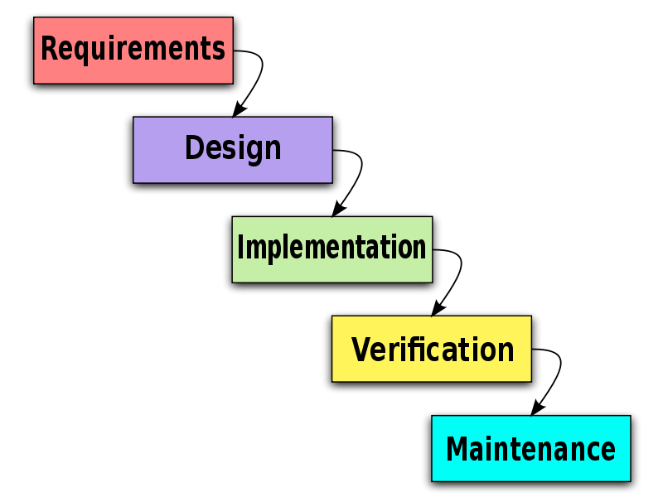

**Fig 3.4 Waterfall Model**

**4. SYSTEM DESIGN**

**4.1 Program Design**

**Design Constraints**

**Standard Development Tools**

* The system shall be built using a standard web page development tool that conforms to either IBM’s CUA standards or Microsoft’s GUI standards.

### **Web Based Product**

* There are no memory requirements
* The computers must be equipped with web browsers such as Google Chrome, Internet explorer.
* The product must be stored in such a way that allows the client easy access to it.
* Response time for loading the product should take no longer than five minutes.
* A general knowledge of basic computer skills is required to use the product

## 

## On-line User Documentation and Help System Requirements

* To implement online user help, link and search fields shall be provided.

## 

## Purchased Components

* Not Applicable

**5. EXTERNAL INTERFACE REQUIREMENTS**

There are many types of interfaces as such supported by the E-Store software system namely; User Interface, Software Interface and Hardware Interface.

### **5.1 User Interfaces**

The user interface for the software shall be compatible to any browser such as Chrome, Internet Explorer, Mozilla or Netscape Navigator by which user can access the system.

### 

### **5.2 Hardware Interfaces**

Since the application must run over the internet, all the hardware shall require to connect internet will be hardware interface for the system. As for e.g. Modem, WAN – LAN, Ethernet Cross-Cable.

### 

### **5.3 Software Interfaces**

The system shall communicate with the Configuration to identify all the available components to configure the places and shall communicate with the content manager to get the product specifications, offerings and promotions.

### 

### **Communications Interfaces**

The system shall use the HTTP protocol for communication over the internet and for the intranet communication will be through TCP/IP protocol suite.

## Licensing Requirements

Not Applicable

## 

## Legal, Copyright, and Other Notices

E-store should display the disclaimers, copyright, word mark, trademark and product warranties of the Marvel electronics and home entertainment.

**5.5 User Interface Design:**

**SCREENSHOTS –**

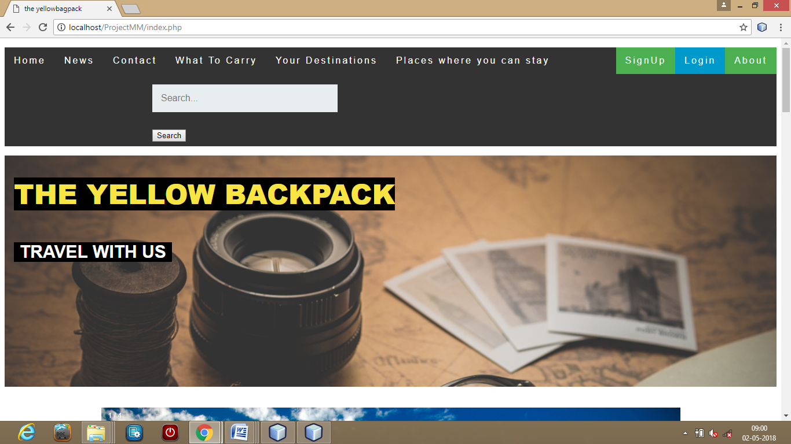

**Snapshot 1. HOME PAGE**

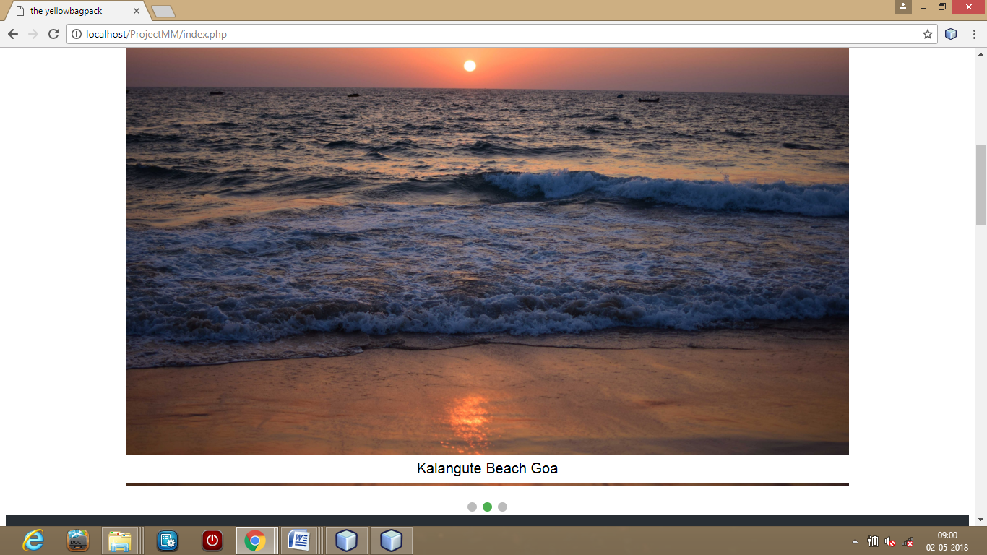

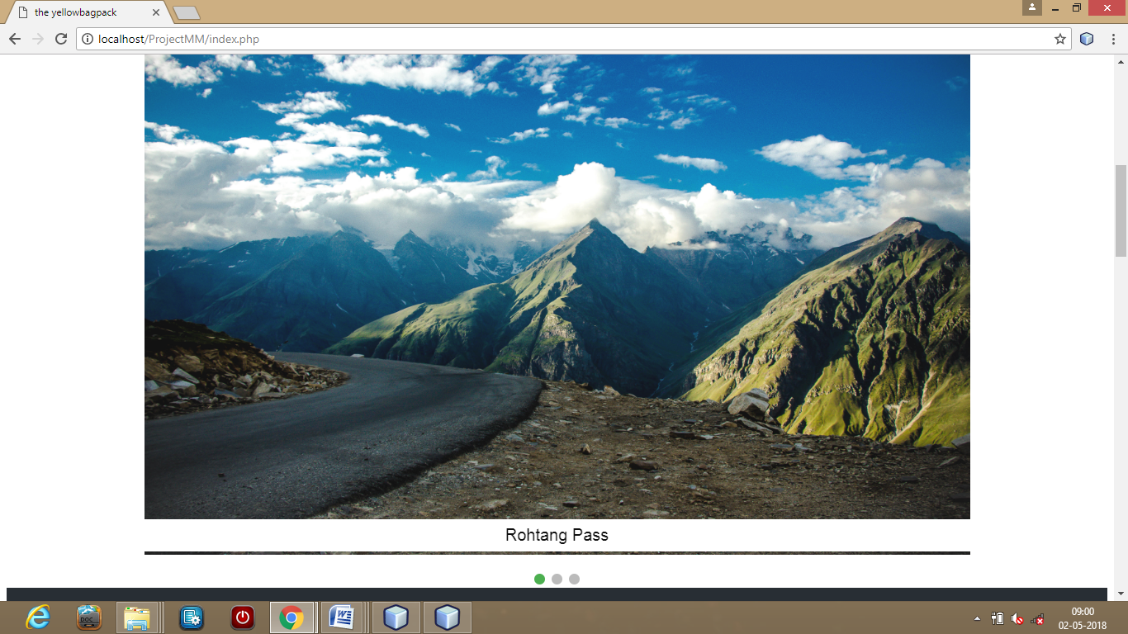



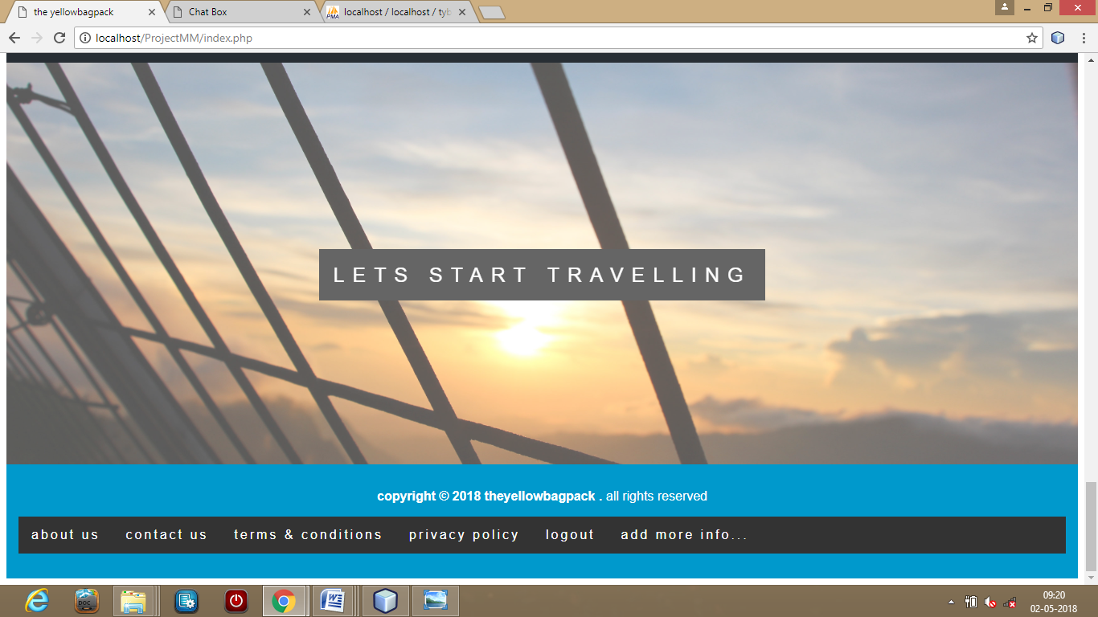

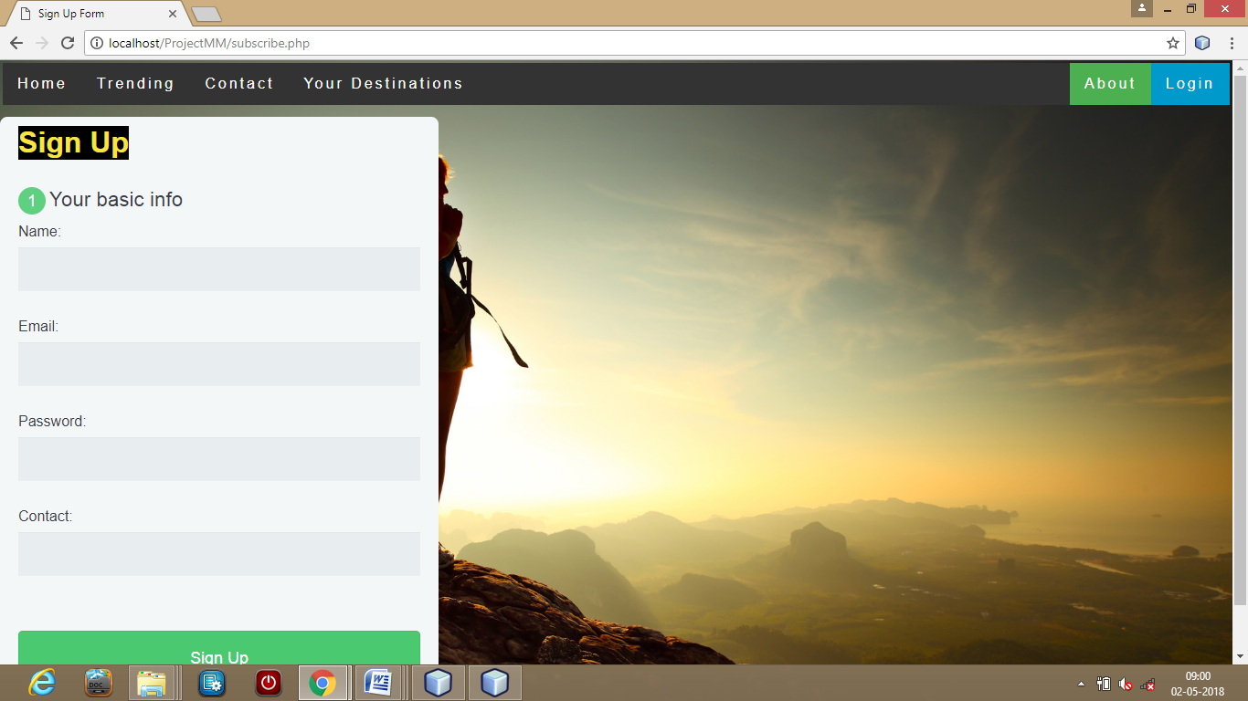 **Snapshot 2. SIGN UP PAGE**

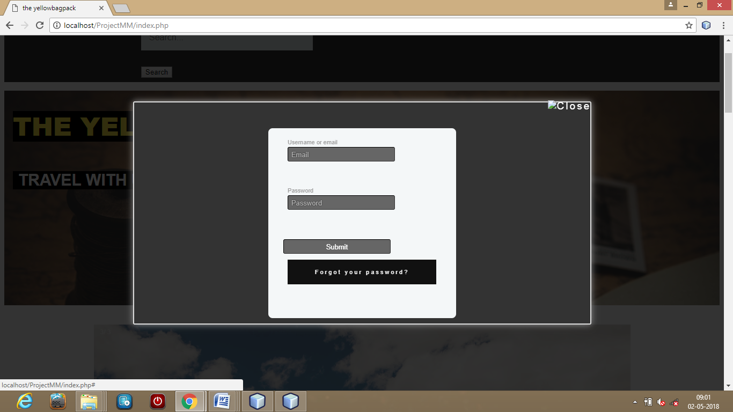

**Snapshot 3. LOGIN PAGE**

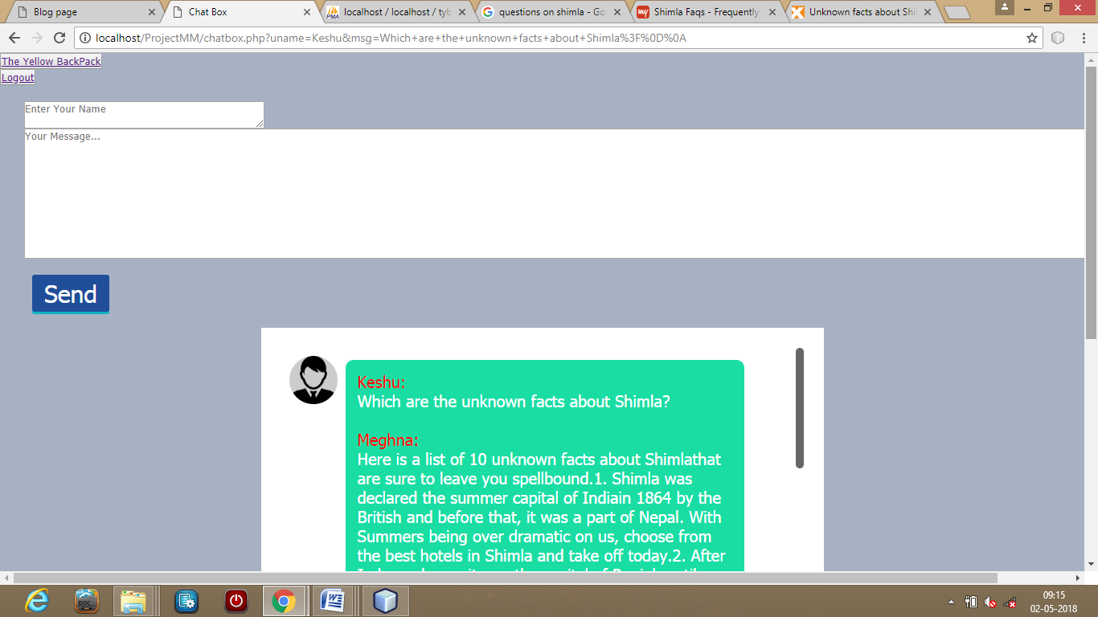 **Snapshot 4. CHAT PAGE 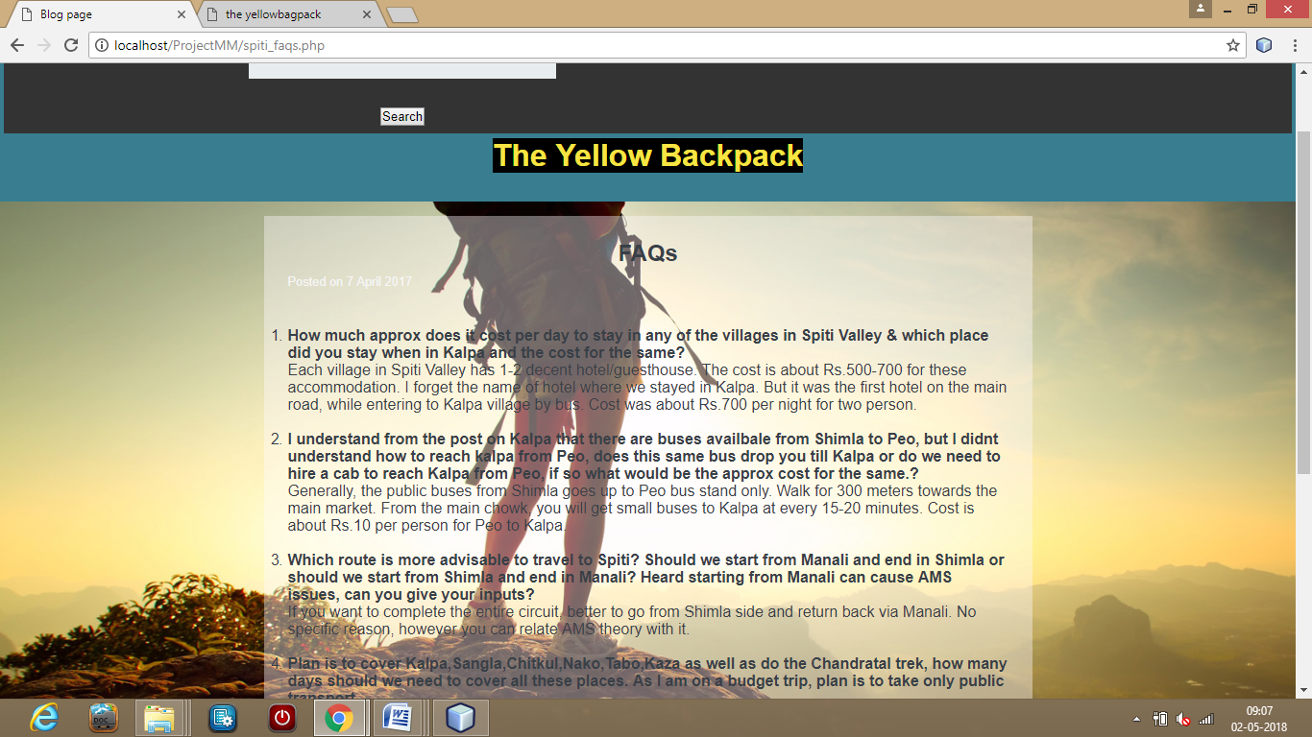 Snapshot 5. FAQ PAGE**

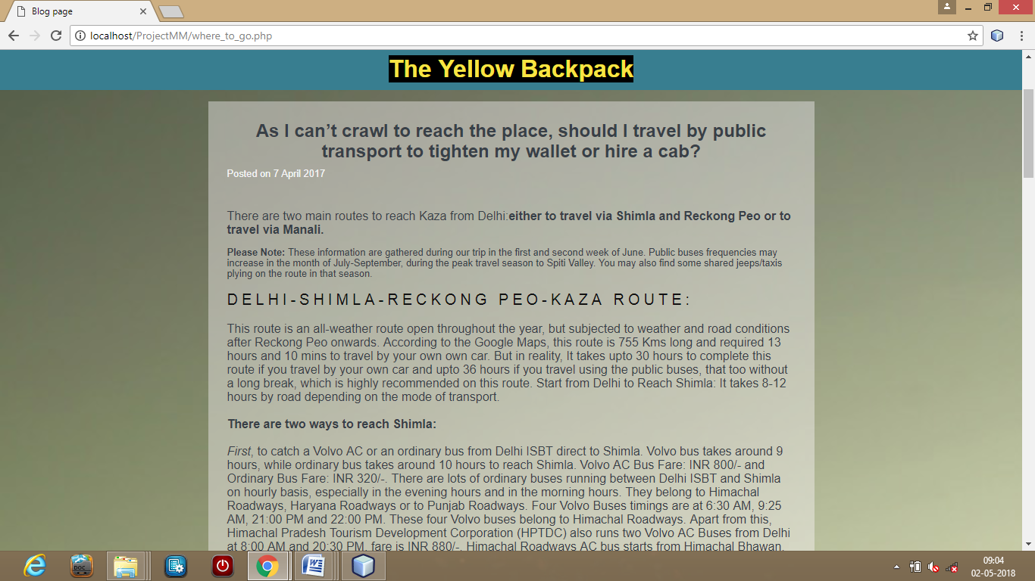 **Snapshot 6. PLACES TO VISIT PAGE**

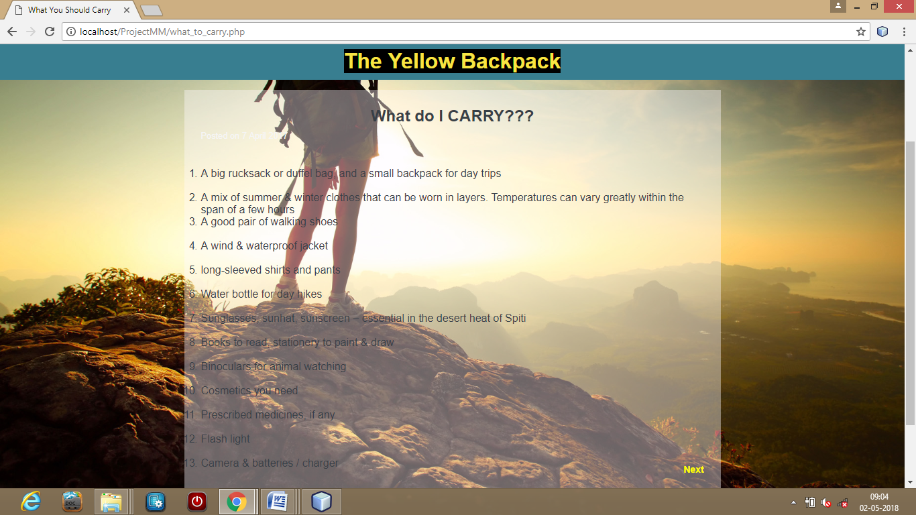

**Snapshot 7. ITEM TO CARRY WHILE TRAVEL PAGE**

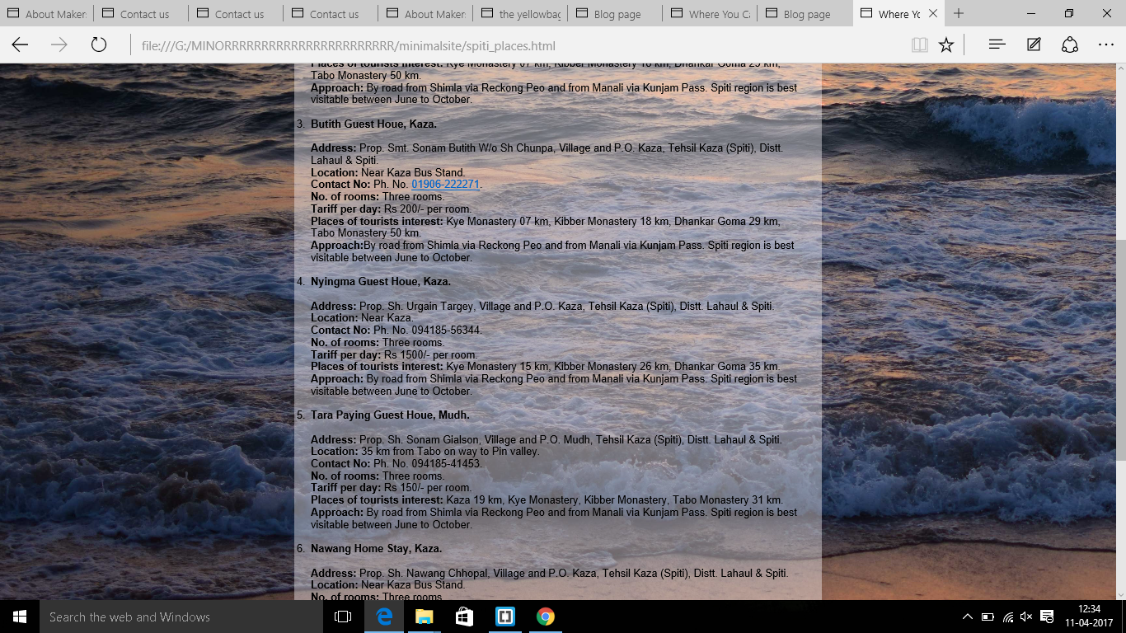 **Snapshot 8. HOTELS TO STAY AT DESTINATION PAGE 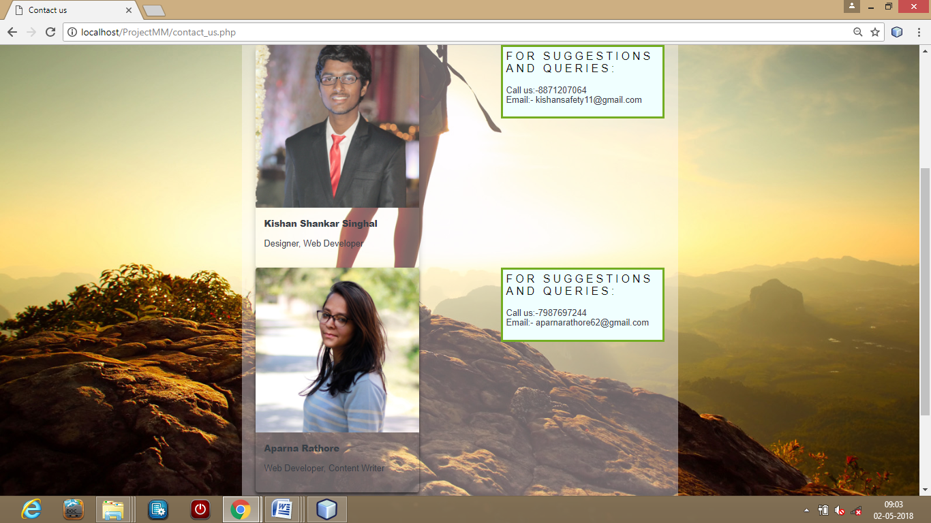 Snapshot 9. CONTACT US**

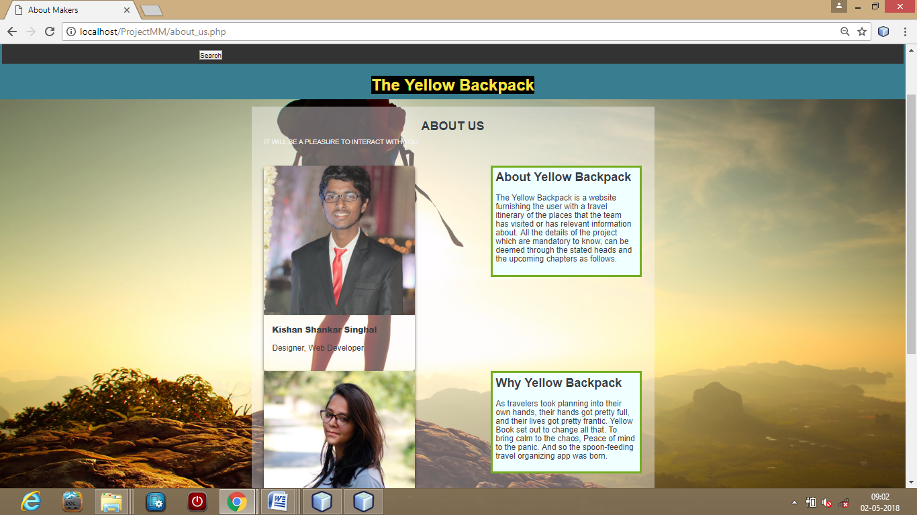 **Snapshot 10. ABOUT US PAGE**

1. **SYSTEM TESTING**

Software testing is a critical element of software quality assurance and represents the ultimate review of specification, design and coding. In fact, testing is the one step in the software engineering process that could be viewed as destructive rather than constructive.

A strategy for software testing integrates software test case design methods into a well-planned series of steps that result in the successful construction of software. Testing is the set of activities that can be planned in advance and conducted systematically. The underlying motivation of program testing is to affirm software quality with methods that can economically and effectively apply to both strategic to both large and small-scale systems.

* **STRATEGIC APPROACH TO SOFTWARE TESTING**

The software engineering process can be viewed as a spiral. Initially system engineering defines the role of software and leads to software requirement analysis where the information domain, functions, behavior, performance, constraints and validation criteria for software are established. Moving inward along the spiral, we come to design and finally to coding. To develop computer software we spiral in along streamlines that decrease the level of abstraction on each turn.

A strategy for software testing may also be viewed in the context of the spiral. Unit testing begins at the vertex of the spiral and concentrates on each unit of the software as implemented in source code. Testing progress by moving outward along the spiral to integration testing, where the focus is on the design and the construction of the software architecture. Talking another turn on outward on the spiral we encounter validation testing where requirements established as part of software requirements analysis are validated against the software that has been constructed. Finally we arrive at system testing, where the software and other system elements are tested as a whole.

UNIT TESTING

MODULE TESTING

SUB-SYSTEM TESING

SYSTEM TESTING

ACCEPTANCE TESTING

Component Testing

Integration Testing

User Testing

**Fig 6.1 Testing Flow Chart**

**UNIT TESTING**

Unit testing focuses verification effort on the smallest unit of software design, the module. The unit testing we have is white box oriented and some modules the steps are conducted in parallel.

1. **WHITE BOX TESTING**

This type of testing ensures that

* All independent paths have been exercised at least once
* All logical decisions have been exercised on their true and false sides
* All loops are executed at their boundaries and within their operational bounds
* All internal data structures have been exercised to assure their validity.

To follow the concept of white box testing we have tested each form .we have created independently to verify that Data flow is correct, All conditions are exercised to check their validity, All loops are executed on their boundaries.

1. **BLACK-BOX TESTING**

Black-Box Testing attempts to find errors in the following categories:

1. Incorrect or missing functions.

2. Interface errors.

3. Errors in the data structure or external database access.

4. Performance errors.

5. Initialization and termination errors

* **BASIC PATH TESTING**

Established technique of flow graph with Cyclomatic complexity was used to derive test cases for all the functions. The main steps in deriving test cases were:

Use the design of the code and draw correspondent flow graph.

Determine the Cyclomatic complexity of resultant flow graph, using formula:

V(G)=E-N+2 or

V(G)=P+1 or

V(G)=Number Of Regions

Where V(G) is Cyclomatic complexity,

E is the number of edges,

N is the number of flow graph nodes,

P is the number of predicate nodes.

**Determine the basis of set of linearly independent paths.**

* **CONDITIONAL TESTING**

In this part of the testing each of the conditions were tested to both true and false aspects. And all the resulting paths were tested. So that each path that may be generate on particular condition is traced to uncover any possible errors.

* **DATA FLOW TESTING**

This type of testing selects the path of the program according to the location of definition and use of variables. This kind of testing was used only when some local variable were declared. The *definition-use chain* method was used in this type of testing. These were particularly useful in nested statements.

* **LOOP TESTING**

In this type of testing all the loops are tested to all the limits possible. The following exercise was adopted for all loops:

All the loops were tested at their limits, just above them and just below them.

All the loops were skipped at least once.

For nested loops test the inner most loop first and then work outwards.

For concatenated loops the values of dependent loops were set with the help of connected loop.

Unstructured loops were resolved into nested loops or concatenated loops and tested as above.

Each unit has been separately tested by the development team itself and all the input have been validated.

1. **CONCLUSION**

There was a lot of fun in making this project. In this project we had to think about the various options which we can provide to user. The implementation was not easy as we had to look into the minute details in order to achieve my goals. We have tried to make this project user friendly and also interactive by providing many features.

The impetus behind building this website is to plan a perfect trip without spending much money and time. As travelers took planning into their own hands, their hands got pretty full, and their lives got pretty frantic. This website is set out to change all that. It will provide all information about your kit i.e. what you should carry while travelling, about your destinations, routes which best suits you and also that Is economical & about accommodation at your destination.

We are satisfied by achieving the goals for which we had planned. A lot of experimental work can be done with this project. Looking forward for any advice which can help us to improve the project.

**REFERENCES AND BIBLIOGRAPHY**

1. HTML- <https://www.w3schools.com/html/default.asp>
2. CSS- <https://www.w3schools.com/css/default.asp>
3. Software engineering By Roger. S .Pressman
4. MYSQL- [www.mysql.com](http://www.mysql.com)
5. [www.google.com](http://www.google.com)
6. Head First HTML with CSS by Chris Schalk (Author), Ed Burns (Author), James Holmes
7. Software Engineering Principles by Roger.S.Pressman
8. System Analysis & Designing by James A. Senn
9. Ian Sommerville Software Engineering

**OTHER DOCUMENTATION AND RESOURCES**

[www.slideshare.net](http://www.slideshare.net)

<http://www.cse.iitd.ernet.in/~cs5080212/Group08_%28>

<https://en.wikipedia.org/wiki/Software_testing>

[www.devdaily.com](http://www.devdaily.com)

<https://www.practo.com/>

<http://www.free-css.com/free-css-templates/page191/wpf-medinova>

<https://www.freshdesignweb.com/css-registration-form-templates/>

[www.microsoftvirtualacademy.com](http://www.microsoftvirtualacademy.com)